Wilmore Solar Tour Map

Oct. 7, 2023

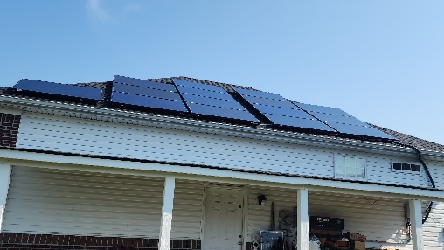

**1**-Dale Shunk Home Array

120 Combs Ln, Wilmore, KY 40390

**Tour starts here.** Get map.

**2**-**Adventure Serve Office has 24 panels**

**50 Campground Rd, Wilmore, KY 40390**

**The Gaddis Family Array - Virtual only**

**4**-**Powdrill Family Array**

**204 Linden St, Wilmore, KY**

**3**-**Mary Miller Home Array of 30 panels**

**417 Akers Dr., Wilmore, KY 40390**

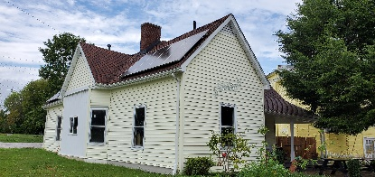

**6**-**The Gazebo on the Green owned by the City of Wilmore at 100 Rice St, Wilmore, KY 40390**

**5**-**The Long Family Array**

**202 Linden St, Wilmore, KY**

**7-Drinklings Coffee Shop**

**100 Rice St, Wilmore, KY. Mention the Solar tour for a discounted cup of coffee.**

**Sayre Home Array of 40 panels on barn – Virtual only**

**The Wilmore Creation Care Solar Tour is organized by the American Solar Energy Society (ases.org) and the Kentucky Solar Energy Society (kyses.org).**

**Wilmore Solar Driving Tour (pg. 2)**

**10B – 204 Woodspointe has ten panels on the west side. side**.

**10A – 204 Woodspointe has five panels on south side**.

**12 – 511 Talbot Drive has eighteen solar panels.**

**11 – 405 Talbot Drive has 22 solar panels.**

**In addition, there are three more solar arrays that did not want their locations listed. One had 12 solar panels and two have 60 solar panels each to actually be off-grid.**

**Thanks for visiting the Wilmore Solar Driving Tour 2023!**